HAVEN STAYS SPEC

1. Description
- Haven Stays is a Wander.com-style AI concierge for luxury vacation rentals.
- Built to demonstrate real business value: guests get instant support, owners capture more leads, and conversions increase.
- The project shows how AdaL agents can power production-ready SaaS workflows with guardrails and secure deployment.

2. Flow Diagrams
The end-to-end flow is: Site → Proxy → Agent → Proxy → Site.

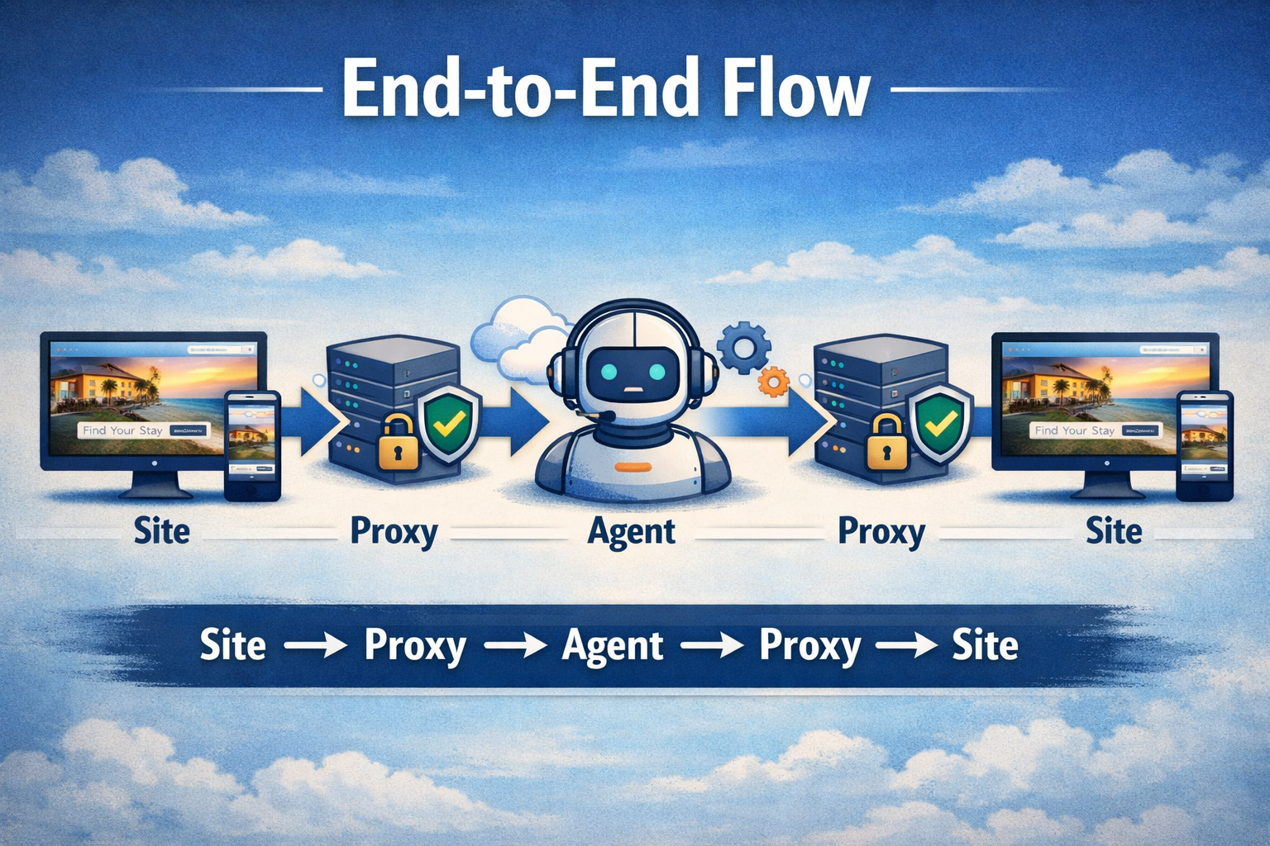

3. Quality Checks
- Guardrails enforced → No hallucinated properties, max 2–3 curated homes, discounts applied deterministically.
- JWT security → Tokens never exposed to the browser.
- Logs validated → Bash/CMD logs show agent creation (201 Created) and successful proxy routing.
- Smoke tests run → Verified property search, quote generation, and lead capture end-to-end.

4. Metric Definition
- Quote accuracy % → Correct discounts and pricing applied.
- Lead capture rate → % of guests submitting inquiries.
- Widget engagement → Click-through and usage frequency.
- Response latency → Average time from query to answer.

5. Example Queries
- “Find me a 7-night stay in Cape Town under $200/night.”
- “Show me 3 curated homes in Bali with a pool.”
- “Build me a quote for 4 guests, 5 nights, with discounts applied.”
- “Capture my details for follow-up.”

This spec shows why Haven Stays exists, how it flows, how quality is ensured, what metrics prove success, and example queries to validate behaviour.
WAP Framework
- What
  - Built Haven Stays, an AI concierge for luxury rentals.
- Actions
  - Designed agent prompts and guardrails.
  - Implemented FastAPI proxy with JWT security.
  - Built storefront with floating concierge widget.
  - Shipped deployment scripts for local and AWS cloud.
- Proof
  - Logs show agent creation (201 Created).
  - Demo video proves end-to-end flow (site → proxy → agent → proxy → site).
  - Guardrails validated: no hallucinations, curated homes only.

